1. Changing detector settings via the new XFP Tools 1

2. Incorrect CAST PRO types showing on XFP Tools (Issue solved by Jamie B, but left in the report) 2

3. Synchronisation of Sounders and VADs 3

4. Test Sounder Group/Test VAD Group (possible observation) 3

5. Read AvOp1/AvOp4 function on panel 4

6. Sounder/VAD Fault Testing 4

7. AvOp2 and AvOp3 issue (both XFP and ZFP) 5

8. No report of Open Circuit 7

**XFP Firmware Version: 14A27 (Renesas processor)**

**XFP Tools Version: 7.2.2**

**Nodes Firmware: 1B:46**

## Changing detector settings via the new XFP Tools

As there is no function on the XFP that allows detector settings to be changed, this must be done using the XFP tools. However, having experimented with this, after the new settings are sent back to the panel from the PC tools, no new configuration data appears to be sent out and the detector continues to perform as though there has been no change. An example of this is trying to change a detector mode. After changing the mode of a detector and sending back the new settings to the panel, this had no effect. When going into the device EEPROM, the ‘Application Flags 2’ section which states the mode of the detector in channel 0 & 1, shows the detector in its original mode rather than the mode it has been re-assigned.

When the PC is disconnected from the panel, the panel does an automatic reset and an initialisation of the devices, however nothing changes.

Following this, a standard CAST multi-sensor detector was tested the same way, switching from its default mode of 3 to mode 5. With this change, the detector should only trigger from Heat Class A1R events and not from any optical events. However, after the mode was changed and sent back to the panel, the detector was smoked with a smoke canister and it still triggered with an optical event. This confirms that it isn’t just an issue with CAST PRO devices.

When the settings are re-downloaded to the PC tools after the test, each device states the new detector mode that it was re-assigned, even though the detector acts as if it is still in its original detector mode.

## Incorrect CAST PRO types showing on XFP Tools (Issue solved by Jamie B, but left in the report)

After addressing CAST PRO voice sounder devices alongside an MCP and detector only devices, when downloading to system to the panel on the XFP tools, two of the voice sounders are appearing as tone sounders. The devices were then re-addressed, re-downloaded to the panel and the same happened.

After further investigation, it appears that the four of the devices’ names are showing incorrectly on the XFP tools. The following devices names need swapping:

CAST PRO HtOp V CAST PRO HtOp T/C

CAST PRO HtOpCO V CAST PRO HtOpCO T/C

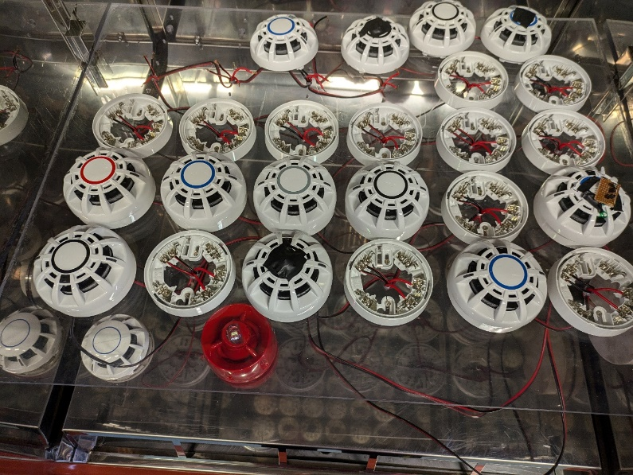**Issue raised with Jamie B. and solved**

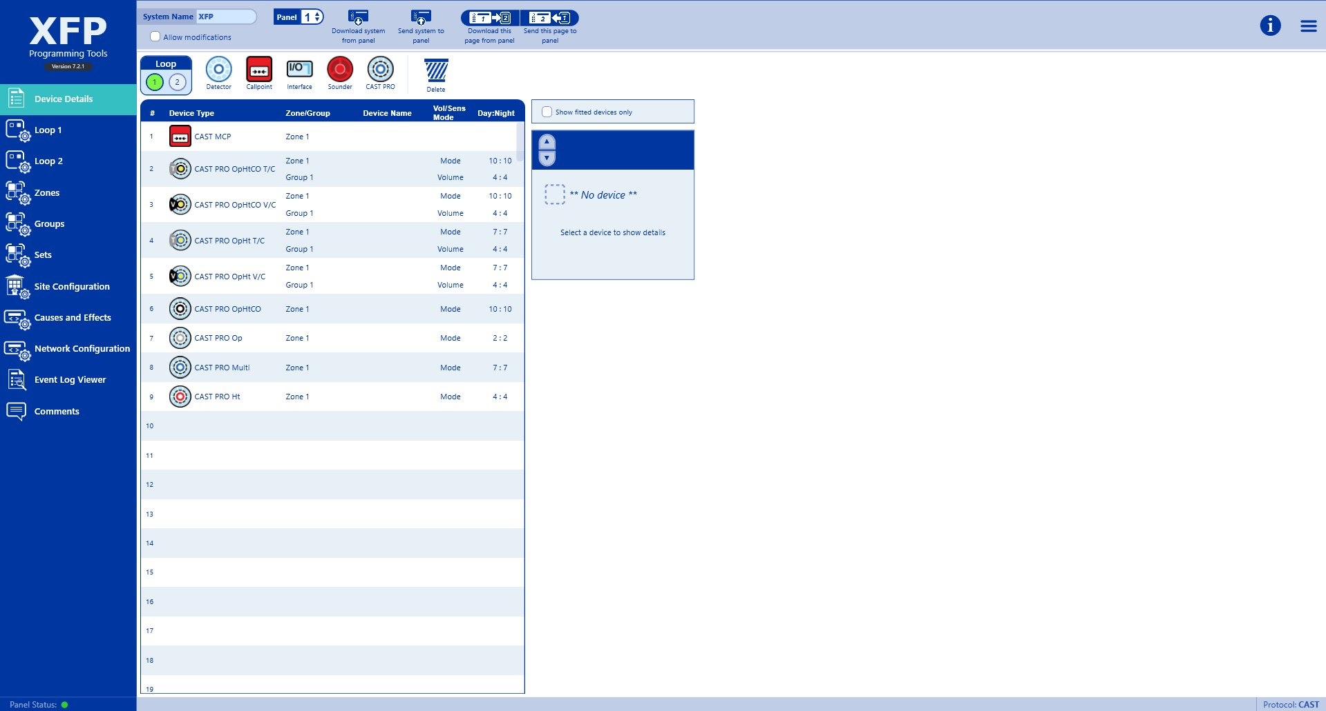

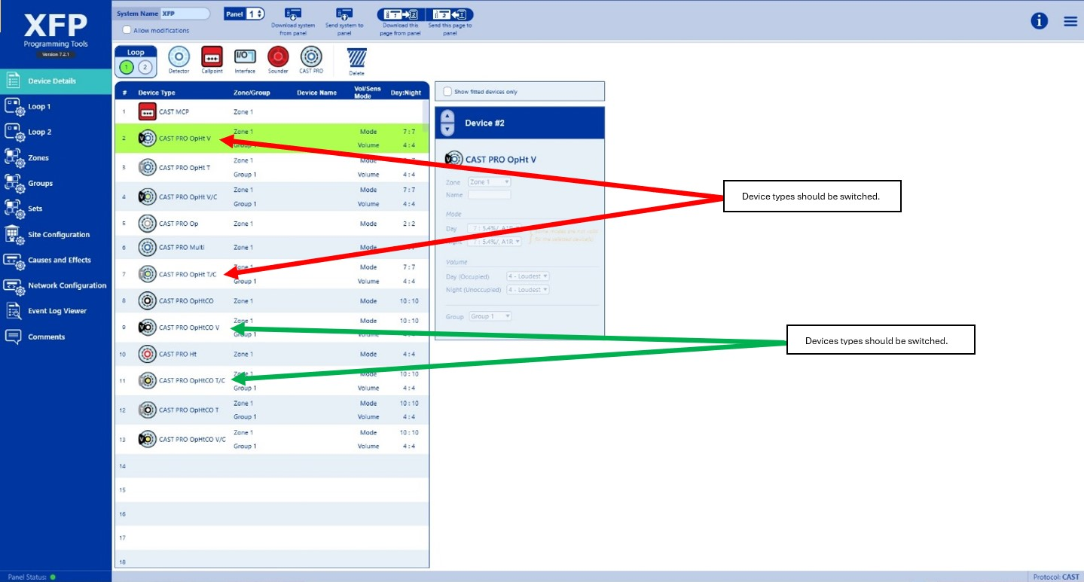

## Synchronisation of Sounders and VADs

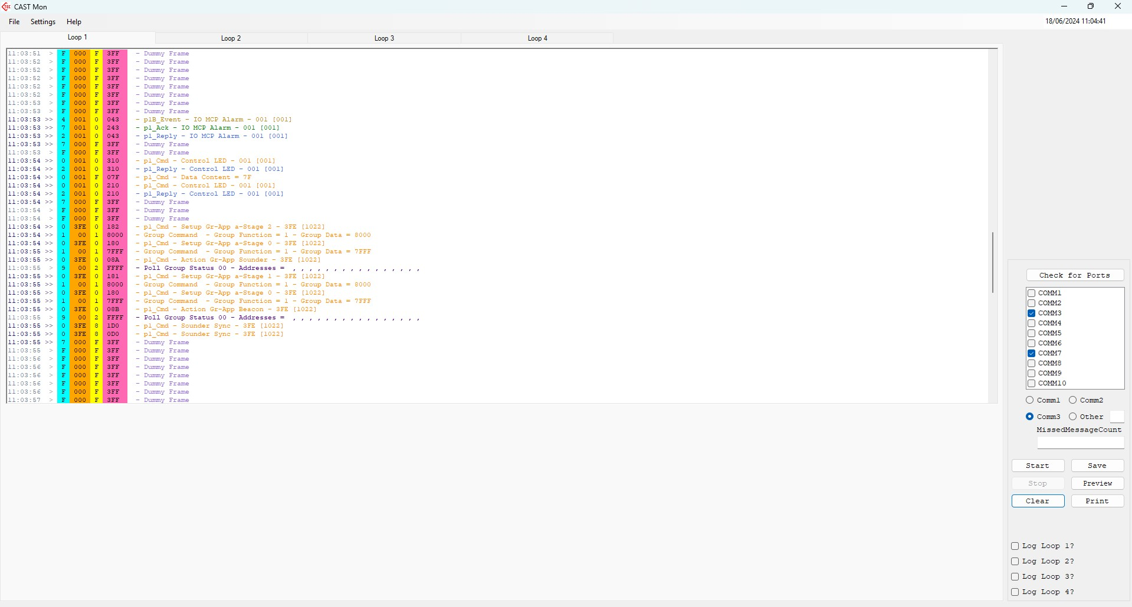There appears to be no synchronisation between the sounders or the VADs when they are active. Four tone sounders were put on a rig together, turned on through the “TEST SOUNDER GROUP” function. Although the ‘sounder sync’ command was sent out, they didn’t sync. The test was repeated using an MCP to trigger the sounders with the result the same. Four voice sounders were then tested using the same methods, which also did not sync. The VADs also did not sync.

As a further test, the same devices were then retested on a ZFP (to confirm this was just an issue with the XFP rather than a general issue), using an MCP to trigger an alarm. The devices sounders and VADs synched and remained in sync for a minimum of 15 minutes.

## Test Sounder Group/Test VAD Group (possible observation)

When using the "TEST SOUNDERS IN GROUPS" function, the VADs also turn on as well as the sounders. For the "TEST VADS IN GROUPS" functions, just the VADs turn on. Not sure if this is intended but it is an observation.

## Read AvOp1/AvOp4 function on panel

The ‘Read AvOp1/AvOp4’ function in the diagnostics menu doesn’t produce readings. This happened for all CAST PRO variants and when tried with a standard CAST detector, this was also the case.

## Sounder/VAD Fault Testing

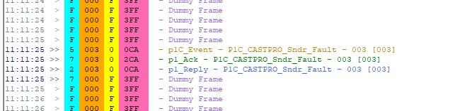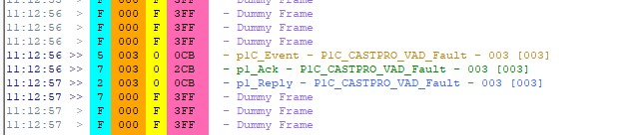When attempting to replicate a sounder fault and a VAD fault, the loop eyes reported both events correctly with the correct event code, however, the panel reported it as a ‘Thermistor O/C fault’.

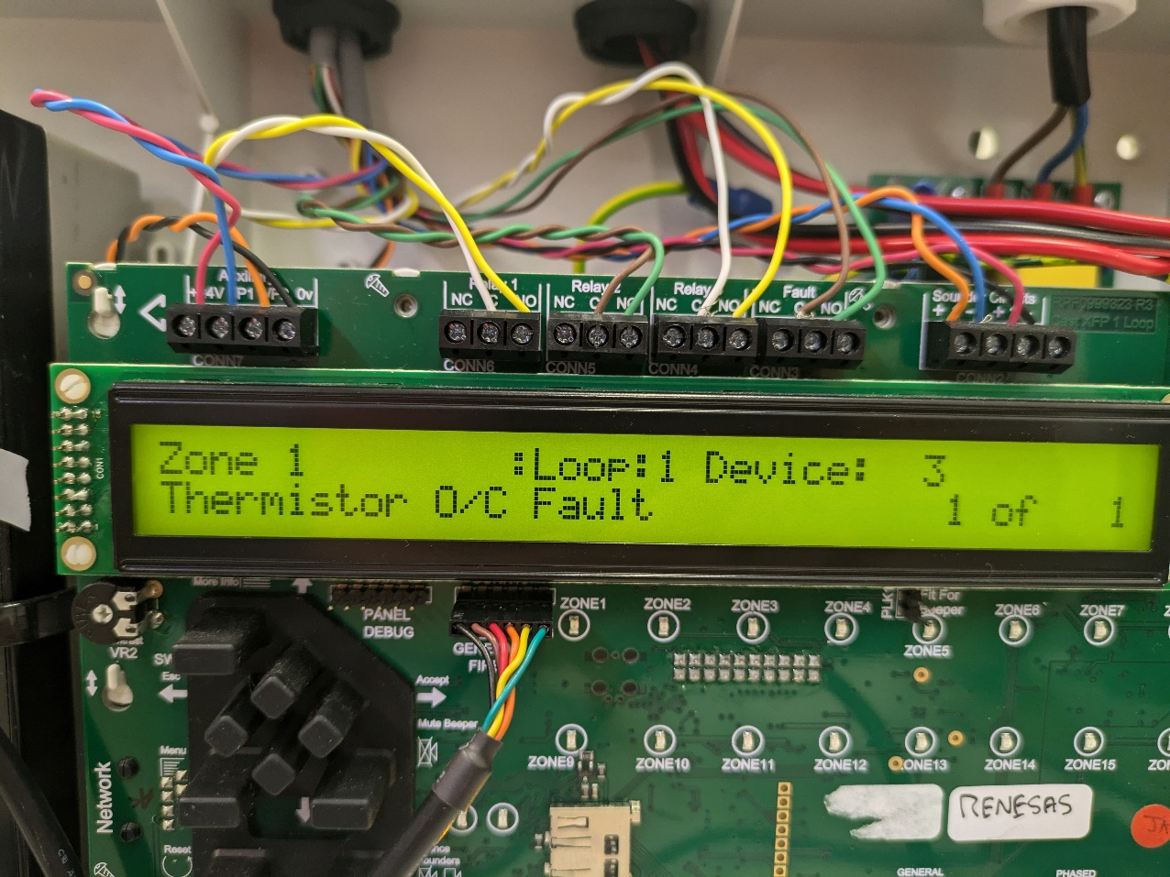This test was done on a CP414TV. Another observation made is that the sounder fault event was reported as soon as the command was sent for the sounder to be activated, whereas the VAD fault was only reported after the command was sent to turn the VAD off (this may be intended, but just an observation).

## AvOp2 and AvOp3 issue (both XFP and ZFP)

Two devices were used to replicate an optical low fault. After the testing, the devices were put back to normal and left on a rig. Since this testing, every time the panel is reset or the devices are re-addressed, AvOp2 and AvOp3 default to the same value, which is a low value (34 on one device and 32 on the other). As a result of this, an optical high fault and a contamination fault are produced. The AvOpRaw and AvOp1 readings are as they should be. As AvOp2 should default to AvOp1 on restart, and AvOp3 to AvOp4, this is a potential bug.

This was also tested on a ZFP with the same result occurring.

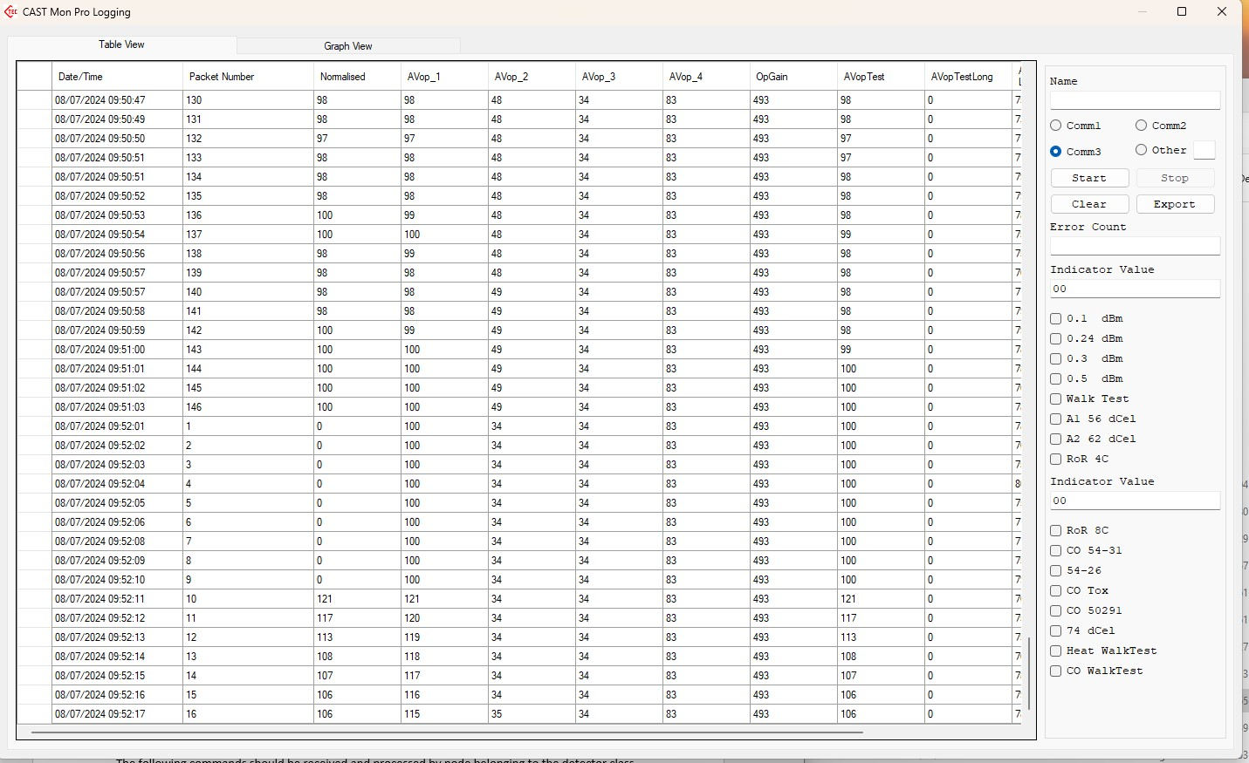Below is an example, where the panel was reset with both AvOp3 and AvOp4 defaulting to 34.

Alongside this, after the panel is reset, the ZFP shows a fault reading ‘Signal too high’.

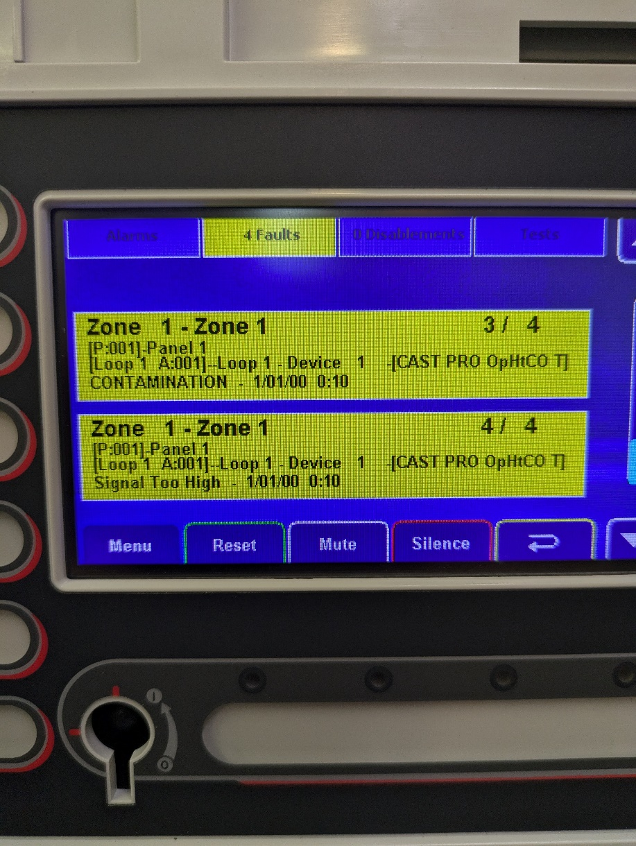

When the loop is restarted, before the initialisation of the device the following events appear on the loop eyes. An RTF file has been saved from the full initialisation process.

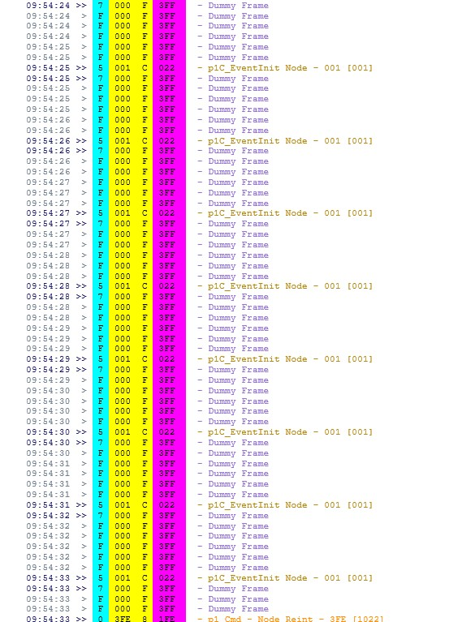

## No report of Open Circuit

When creating an open circuit on the loop, either end or part way through the loop, the panel fails to report an open circuit fault. The double poll from each loop end on the loop eyes acknowledges the fact there is an O/C , however there is no report or event sent out. The setup was left for an hour and still no report.